1. Here is how my repository looks on the Ubuntu server.
2. 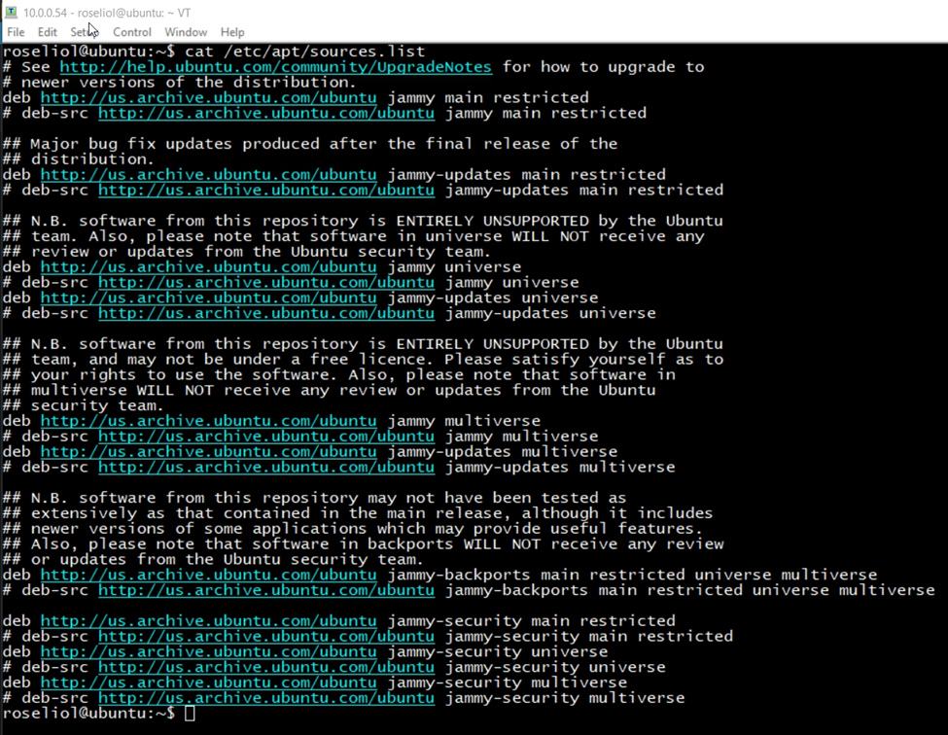
3. If you need to add or modify the file you can open it with a text editor such as vim or nano
4. Here is how it would look if it were to be opened with the vim editor. Vim is a text editor where you can create files or edit ones that have been already created.
5. Text

   Description automatically generated